**Finding Slope B1 = f(strain,li)**

Model 9:

10mm (Pressurizing): c0 = -182.7177 c1 =0.3306

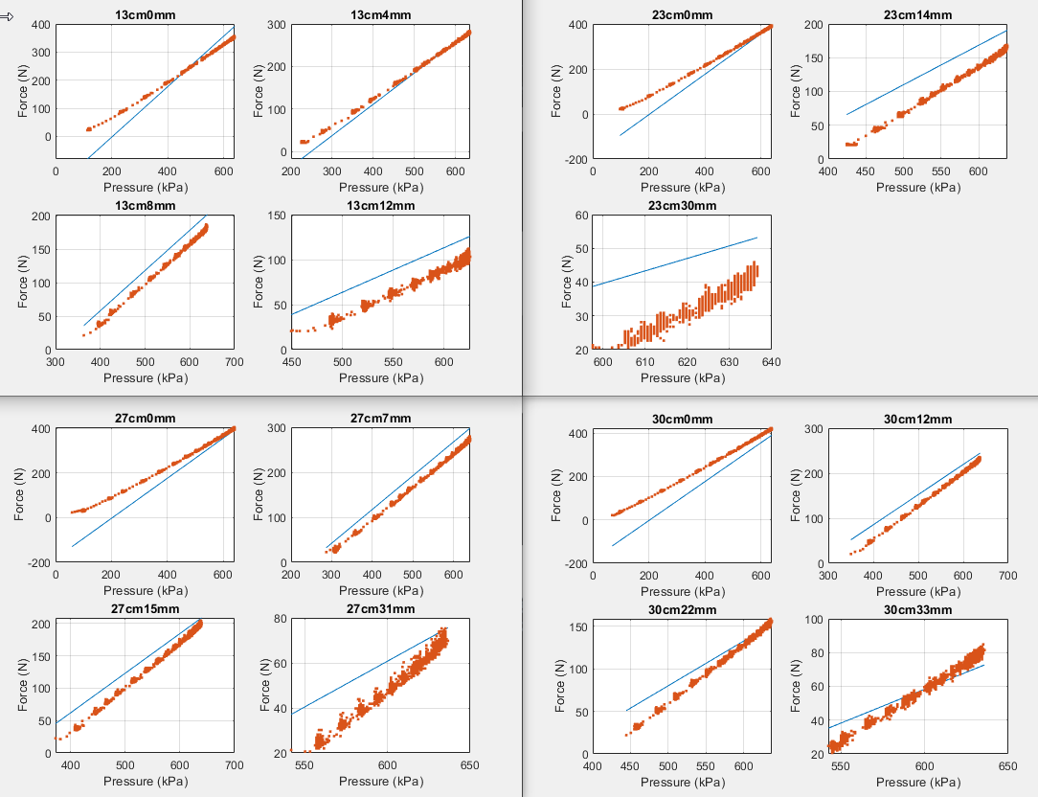10mm (Depressurizing): c0 =-63.5650 c1 = 0.2426

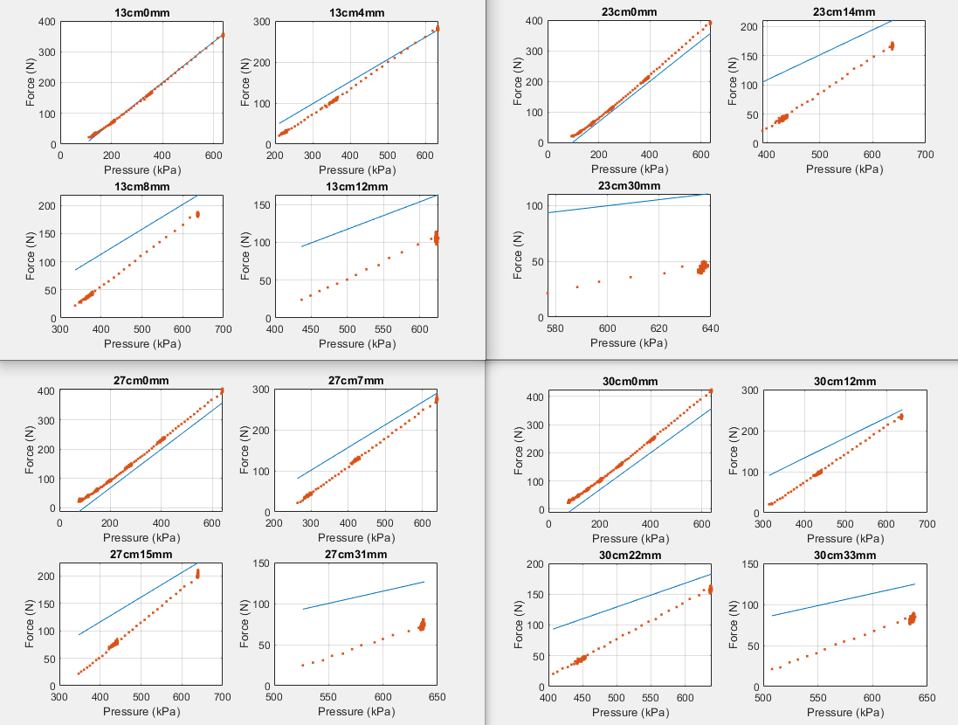

20mm(Pressurizing): c0 = -327.3749 c1 =0.8833

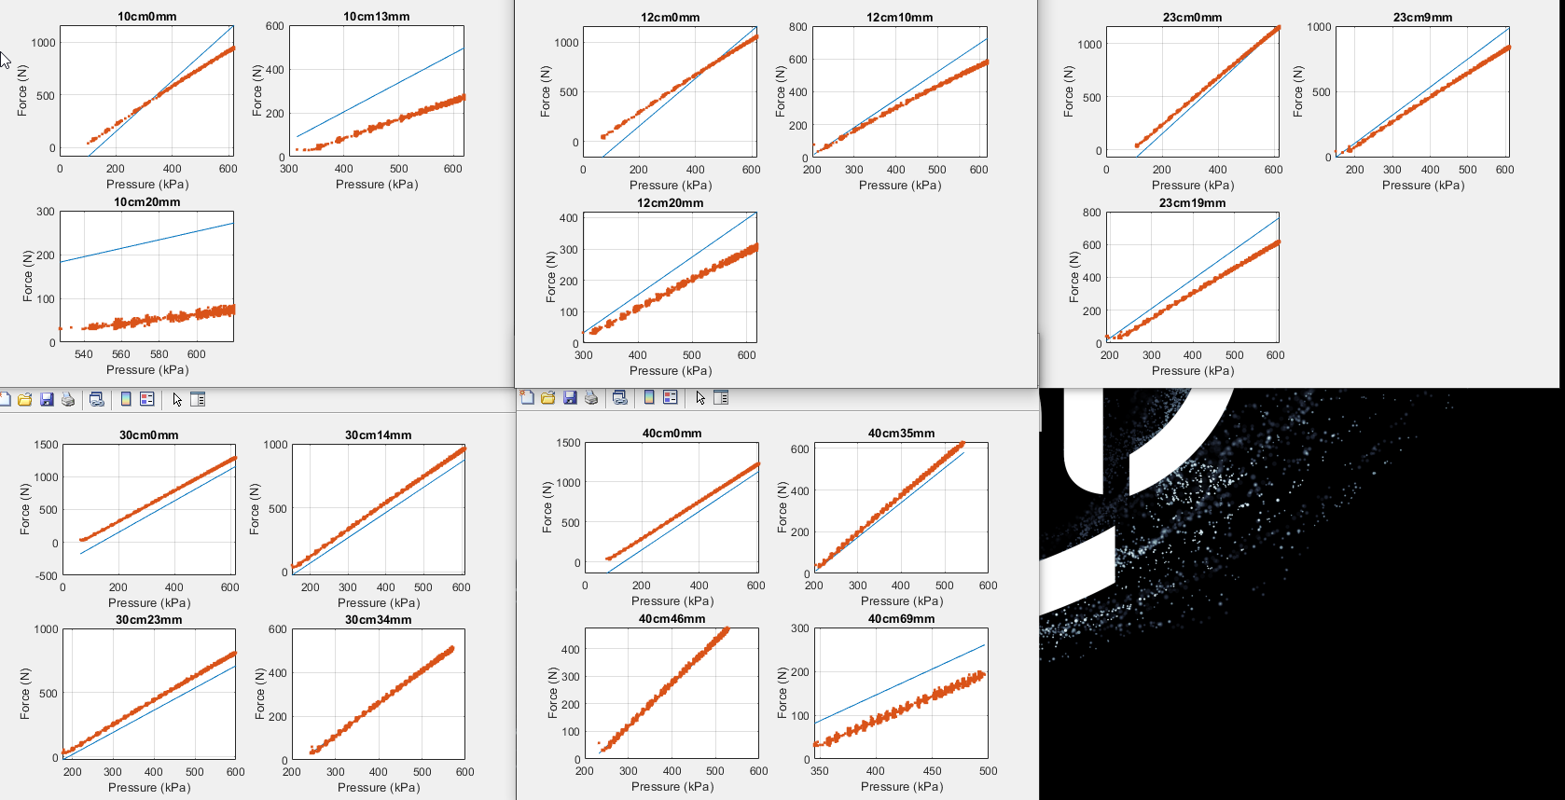

20mm (Depressurizing) : c0 = -153.3861 c1 = 0.7416

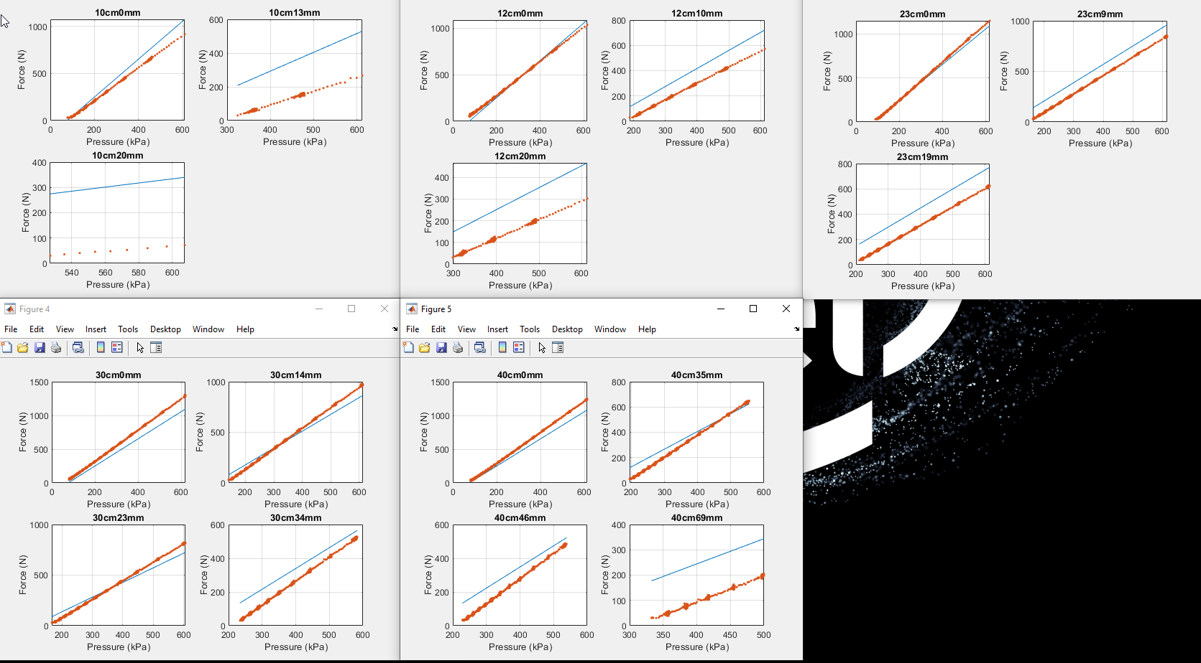

**Model : Force = c0 + c1(1-Erelative)P**

10mm (P): c0 = -58.8616 c1 = 0.6842

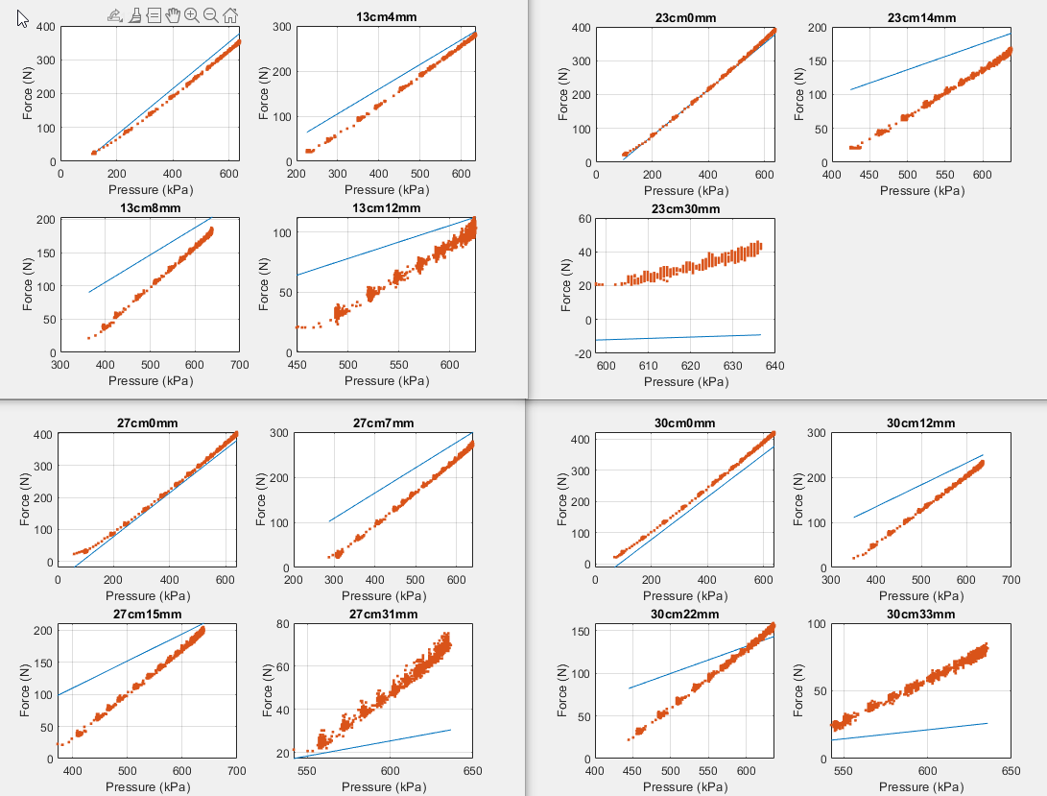

10mm (DP) : c0 = -24.2739 c1=0.6277

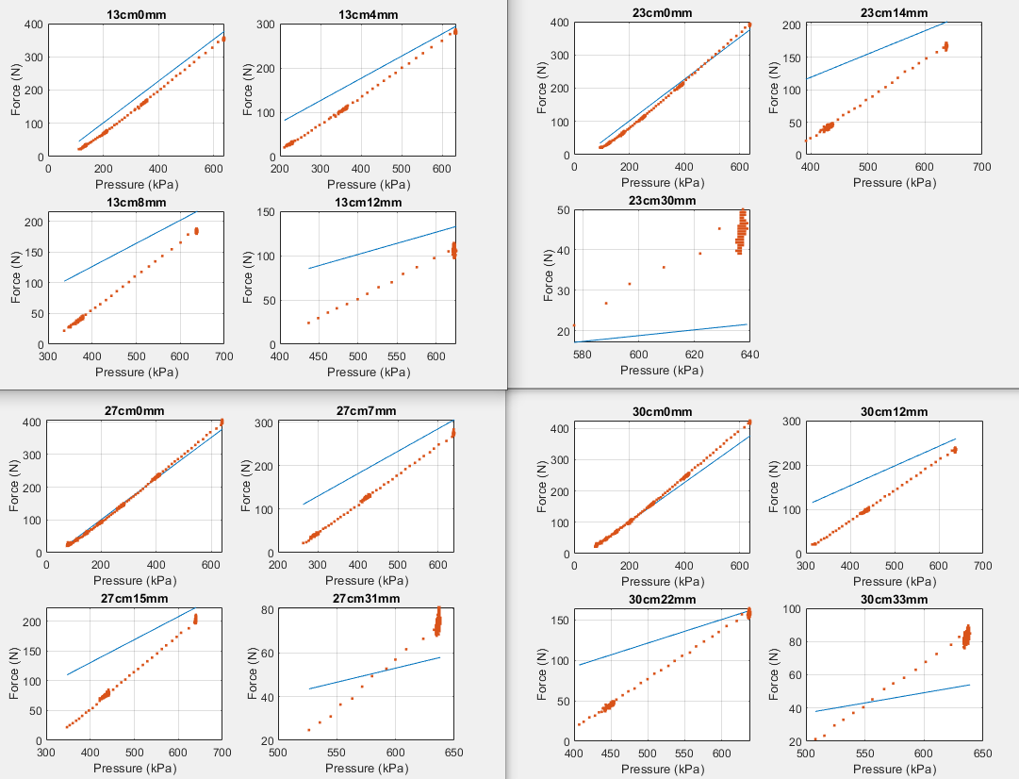

20mm (Pressurizing) : c0 = -177.3787 c1 = 2.1383

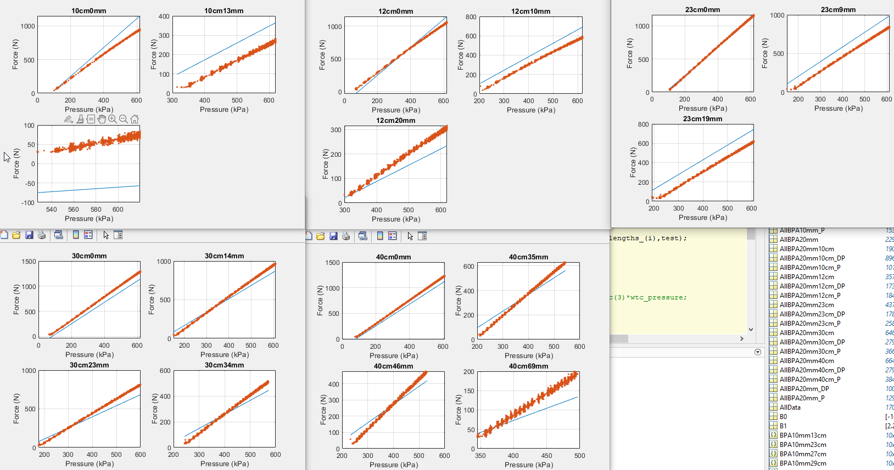

20mm (Depressurizing): c0 = -146.7916 c1 = 2.0810

